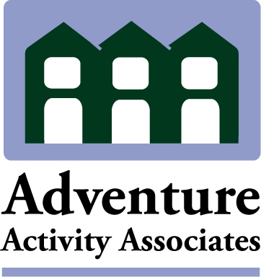

Learning Outside of the Classroom “Top Up” Inspections

There are providers who hold Adventuremark or an Adventure Activity Licensing Service (AALS) licence and who want the Learning Outside the Classroom Quality badge.

AAIAC, in association with the LOtC Council, have devised a system of “Top Up” inspections for the areas of operation that are required by the LOTC badge but which have not already been assessed. The Top Up inspection will assess the provider against the LOTC Quality Indicators.

What happens if my organisation holds a number of licences?
Some large organisations may have a number of operating bases which hold AALS licences. Each licence holder will require a separate “Top Up” inspection and will be awarded their own LOtC badge i.e. it is the licenced provider and not the organisation that is awarded the badge.

Who can provide Top Up inspections?
“Top Up” inspections can only be conducted by AAIAC approved LOTC inspectors.

How long is the badge valid for?
The LOTC badge will be valid for 2 years from the date of issue assuming that the provider continues to hold an AALS Licence or Adventuremark. Badges and licences need not run concurrently but for the badge to be valid providers must hold either an AALS licence or Adventuremark.

Fees

Top Up inspections cost £615 (+ VAT).

